State of Louisiana
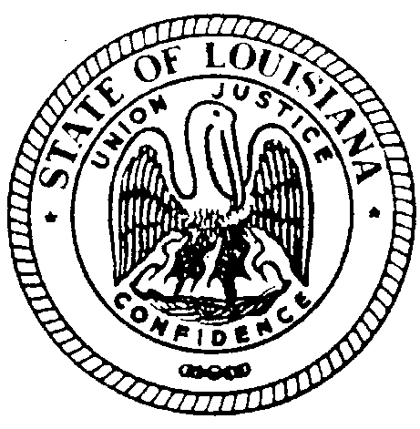
THE LOUISIANA BOARD FOR HEARING AID DEALERS

MINUTES OF MEETING
January 25, 2020
GOODWOOD LIBRARY BATON ROUGE, LOUISIANA

The 79th Meeting of the Louisiana Board for Hearing Aid Dealers was called to order at 1:38pm on
January 25, 2020 at East B.R. Goodwood Library Baton Rouge, LA by Kirt Loupe, Board Chairman.

Visitor(s): NONE

The roll was called. Those present were Kirt Loupe, Jeremy Stroud, Emily Goerges, Cherry Collum, Jenelle Sharp, Bryan Stinson & Barbara Matens. Quorum established. Dina Zeevi, the Board’s Administrative Secretary was present to take the minutes of the meeting.

PUBLIC COMMENTS- NONE

AGENDA

Bryan Stinson made a motion to amend the Agenda to add Treasurer-Secretary Report & Admin.-Secretary Report to Agenda. Emily Fonte 2nd the motion. All in favor, approved unanimously.

MINUTES

Minutes of the June 19, 2019 meeting were presented to the Board in form of an advanced email. Barbara Matens made a motion to add Discussion of Licensing Act Statute Updates under New Business. Bryan Stinson 2nd the motion. All in favor, approved unanimously.

TREASURER REPORT

Presented by Jeremy Stroud. YTD Budget presented.

TREASURER-SECRETARY REPORT

Presented by Dina Zeevi

ADMINISTRATIVE SECRETARY REPORT

Presented by Dina Zeevi

COMMITTEE REPORTS

ETHICS COMMITTEE: Presented by Jenelle Sharp. 4 Complaints received-No violations.
EXAMINATION COMMITTEE: Presented by Bryan Stinson. 1 Practical Exam Candidate in Jan. 2020- Failed
LEGISLATIVE COMMITTEE: Presented by Jeremy Stroud. Nothing to report.
OFFICE INSPECTION COMMITTEE: Presented by Emily Fonte. Nothing to report.

UNFINISHED BUSINESS

HIPAA REQUIREMENT- Presented by Dina Zeevi- contacting FDA for specific requirements for offices to provide HIPAA paperwork.

NEW BUSINESS

IHS Convention- Chairman Kirt Loupe attended the convention & shared information received from the Convention. Discussion of cost of Convention held. Bryan Stinson made a motion to remove Convention Line item from upcoming budget. Cherry Collum 2nd the motion. All in favor, unanimously approved.

Dissolution of Office Inspection Committee- Emily Fonte made a motion to dissolve the Committee and have inspection forms submitted directly to Administrative-Secretary for filing into LABHAD records. Cherry Collum 2nd the motion. All in favor, unanimously approved.

ELECTION OF OFFICERS

Jeremy Stroud-Chairman. Emily Fonte-Treasurer-Secretary. Kirt Loupe-Ethics Committee Chairman. Jeremy Stroud-Legislative Committee Chairman. Bryan Stinson-Exam Committee Chairman.
Bryan Stinson made a motion to accept new officers. Jenelle Sharp 2nd the motion. All in favor, approved unanimously.

DATE AND LOCATION OF NEXT 2020 MEETING/PRACTICAL EXAMINATION

Chairman Jeremy Stroud set next meeting/practical examination date and location:
Practical Examination: Saturday June 6, 2020 9:00am-12:00pm @East Baton Rouge Goodwood Public Library
LABHAD Meeting: Saturday June 6, 2020 1:30pm-4:00pm @ East Baton Rouge Goodwood Public Library

Motion made by Emily Fonte to adjourn meeting. Kirt Loupe 2nd the motion. All in favor, unanimously approved. Meeting ended at 2:53pm

